Machine Learning for Artificial Intelligence Engineering, Winter Term 2025, Homework 2 Report

Submission Details
Item | Value
Student Name I | Philipp Doerfler
Student ID I | 01031163
Student Name II | Joachim Rath
Student ID II | 51811071
Course | Machine Learning for Artificial Intelligence Engineering
Due Date | 23.01.2026 23:59
1 General Remarks
The submission was run with Python 3.11.5 in VS Code.

2 Exploratory Data Analysis

2.1 Plots

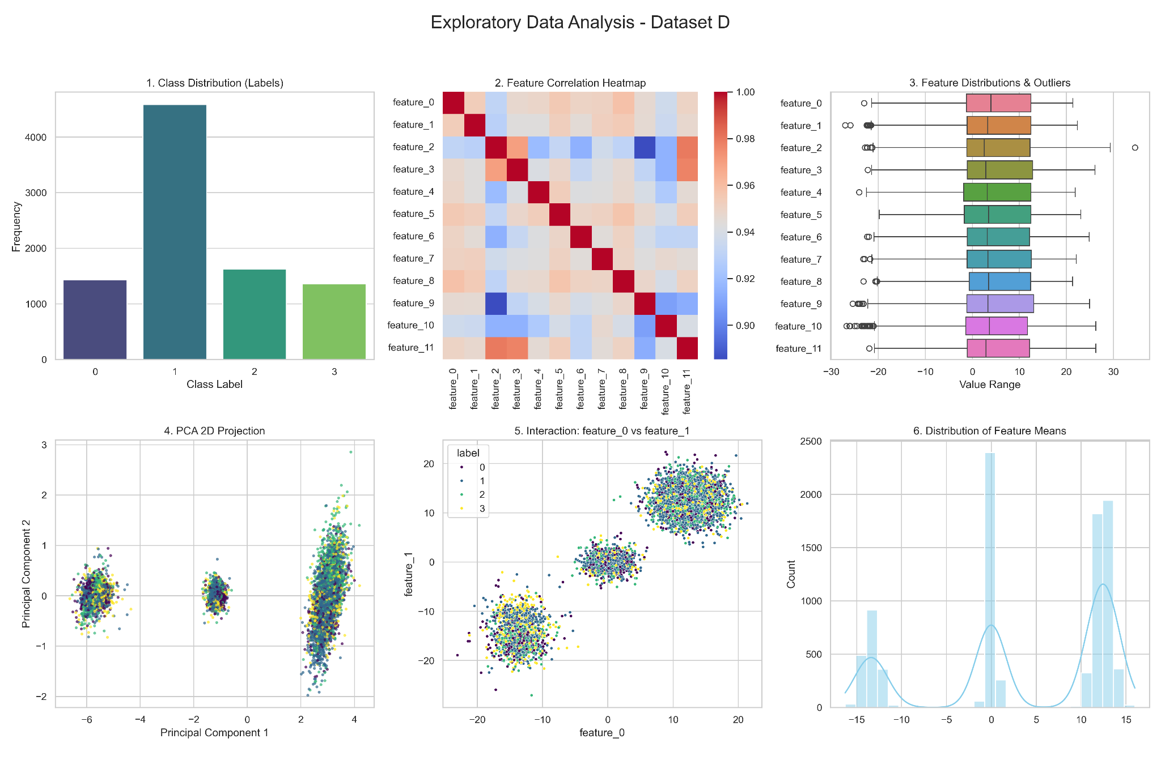

2.2 Interpretation of the plots
Plot 1: The analysis of dataset D reveals a class imbalance, with Class 1 being the dominant category, accounting for >50% of the total samples. This imbalance directly justifies the assignment's requirement to use the Macro-F1 score for evaluation, as this metric ensures that the performance on the minority classes (0, 2, and 3) is weighted equally to the majority class, preventing the model from appearing successful by simply over-predicting the most frequent class.

Plot 2: The correlation heatmap shows moderate dependencies between several features, suggesting that regularized models like XGBoost will be more robust against redundancy.

Plot 3: The significant outliers identified in the boxplots confirm the existence of sensor noise, which we will address using a Gaussian Mixture Model (GMM) for probabilistic outlier detection.

Plot 4 & 5: The PCA 2D projection (Plot 4) and feature interactions (Plot 5) demonstrate that the data is not linearly separable, necessitating the use of non-linear ensemble methods to capture complex decision boundaries.

Plot 6: Shows varying scales and offsets across the dataset, which confirms the necessity of Standard Scaling to ensure numerical stability and faster convergence for our chosen architectures.

3 Baseline Model

3.1 Validation strategy
To evaluate our models locally and represent their actual performance on the leaderboard, we employed Stratified 5-Fold Cross-Validation. This strategy was chosen specifically to address the significant class imbalance identified in the EDA (Class 1 dominance >50%). Stratification ensures that the proportion of samples for each class is preserved in every fold, preventing the "vanishing minority class" problem that can occur with random splitting. To avoid label leakage, we utilized an sklearn.pipeline.Pipeline. This ensures that the preprocessing step (StandardScaler) is fitted only on the training folds within the loop and then applied to the validation folds, strictly separating training statistics from validation data.

3.2 Report your choice of K. Using the baseline model, report Precision, Recall, F1, Accuracy (for all classes), and the macro-averaged F1 score
We trained a KNeighborsClassifier as our baseline. Since KNN relies on Euclidean distance, we applied Standard Scaling to normalize the feature distributions. After performing a grid search for K∈{1,3,…,21}, we found that K=9 yielded the best generalization performance.
The detailed performance metrics for the baseline model (K=9) are reported below:

Class | Precision | Recall | F1-Score | Support
0 | 0.6213 | 0.4396 | 0.5149 | 1433
1 | 0.6758 | 0.8815 | 0.7651 | 4584
2 | 0.5515 | 0.4782 | 0.5122 | 1625
3 | 0.6432 | 0.2828 | 0.3928 | 1358
Global Accuracy |  |  | 0.6480 | 9000
Macro Avg | 0.6229 | 0.5205 | 0.5463 | 9000

The baseline achieves a Global Accuracy of 64.8%, but the Macro-F1 score is significantly lower at 54.6%. This discrepancy highlights the model's bias toward the majority class (Class 1, F1=0.76), while it struggles significantly with Class 3 (Recall=0.28). This confirms that optimizing for Macro-F1 is the correct objective for the subsequent experiments.

4 Model Experimentation & Validation
Building upon our baseline established in Task 3, we aimed to improve classification performance through an iterative experimentation process. We utilized a Stratified 5-Fold Cross-Validation strategy to ensure robust local evaluation.
We explored a wide range of architectures, starting from a simple KNN Baseline, moving to Random Forests, and finally experimenting with complex Stacking Ensembles.
While our local validation suggested that a Stacking Classifier (combining Random Forest, XGBoost, and KNN) yielded the highest theoretical F1-score, our testing on the public leaderboard revealed that a single, robustly tuned XGBoostmodel generalized better to unseen data.

4.1 Metrics report per experiment
The table below summarizes our key experiments:

Exp. | Model Architecture | Preprocessing | Key Configuration | Accuracy | Macro F1
1 | KNN (Baseline) | StandardScaler | k=9 | 0.6480 | 0.5463
2 | Random Forest | Raw Data | n_estimators=100 | 0.6912 | 0.6083
3 | Random Forest | Raw Data | class_weight='balanced' | 0.6878 | 0.6020
4 | XGBoost | Raw Data | Default Settings | 0.6749 | 0.5892
5 | XGBoost | StandardScaler | lr=0.1, depth=3 | 0.6578 | 0.5602
6 | XGBoost (Selected) | PowerTransformer | subsample=0.8, depth=6 | 0.6734 | 0.5839
7 | XGBoost | Feature Eng. + PT | Added Mean/Std Stats | 0.6731 | 0.5852
8 | Voting Classifier | StandardScaler | Soft Voting (RF+XGB) | 0.6868 | 0.6023
9 | MLP (Neural Net) | StandardScaler | 2 Hidden Layers (64,32) | 0.6609 | 0.5709
10 | Stacking Classifier | Mixed | RF + XGB + KNN | 0.6916 | 0.6130

Experiment 1: KNN Baseline (StandardScaler, k=9)

Class | Precision | Recall | F1-Score | Support
0 | 0.6213 | 0.4396 | 0.5149 | 1433
1 | 0.6758 | 0.8815 | 0.7651 | 4584
2 | 0.5515 | 0.4782 | 0.5122 | 1625
3 | 0.6432 | 0.2828 | 0.3928 | 1358
Global Accuracy |  |  | 0.6480 | 9000
Macro Avg | 0.6230 | 0.5205 | 0.5463 | 9000

Experiment 2: Random Forest (Raw Data)

Class | Precision | Recall | F1-Score | Support
0 | 0.6399 | 0.4787 | 0.5477 | 1433
1 | 0.7236 | 0.8857 | 0.7965 | 4584
2 | 0.6363 | 0.5889 | 0.6117 | 1625
3 | 0.6371 | 0.3814 | 0.4772 | 1358
Global Accuracy |  |  | 0.6912 | 9000
Macro Avg | 0.6592 | 0.5837 | 0.6083 | 9000

Experiment 3: Random Forest (Balanced Weights)

Class | Precision | Recall | F1-Score | Support
0 | 0.6728 | 0.4578 | 0.5449 | 1433
1 | 0.7043 | 0.8983 | 0.7896 | 4584
2 | 0.6490 | 0.5643 | 0.6037 | 1625
3 | 0.6523 | 0.3675 | 0.4701 | 1358
Global Accuracy |  |  | 0.6878 | 9000
Macro Avg | 0.6696 | 0.5720 | 0.6020 | 9000
Experiment 4: XGBoost (Raw Data)

Class | Precision | Recall | F1-Score | Support
0 | 0.6268 | 0.4759 | 0.5411 | 1433
1 | 0.7221 | 0.8689 | 0.7887 | 4584
2 | 0.6021 | 0.5551 | 0.5776 | 1625
3 | 0.5646 | 0.3733 | 0.4495 | 1358
Global Accuracy |  |  | 0.6749 | 9000
Macro Avg | 0.6289 | 0.5683 | 0.5892 | 9000

Experiment 5: XGBoost (StandardScaler)

Class | Precision | Recall | F1-Score | Support
0 | 0.6094 | 0.4452 | 0.5145 | 1433
1 | 0.6929 | 0.8822 | 0.7762 | 4584
2 | 0.5882 | 0.4923 | 0.5360 | 1625
3 | 0.5786 | 0.3225 | 0.4142 | 1358
Global Accuracy |  |  | 0.6578 | 9000
Macro Avg | 0.6173 | 0.5356 | 0.5602 | 9000

Experiment 6: XGBoost + PowerTransformer -> Leaderboard Score: 72.54

Class | Precision | Recall | F1-Score | Support
0 | 0.6314 | 0.4627 | 0.5340 | 1433
1 | 0.7112 | 0.8807 | 0.7869 | 4584
2 | 0.6036 | 0.5378 | 0.5688 | 1625
3 | 0.5896 | 0.3586 | 0.4460 | 1358
Global Accuracy |  |  | 0.6734 | 9000
Macro Avg | 0.6340 | 0.5600 | 0.5839 | 9000
Experiment 7: XGBoost + Feature Eng.

Class | Precision | Recall | F1-Score | Support
0 | 0.6363 | 0.4676 | 0.5390 | 1433
1 | 0.7142 | 0.8750 | 0.7865 | 4584
2 | 0.5949 | 0.5458 | 0.5693 | 1625
3 | 0.5833 | 0.3608 | 0.4459 | 1358
Global Accuracy |  |  | 0.6731 | 9000
Macro Avg | 0.6322 | 0.5623 | 0.5852 | 9000

Experiment 8: Voting Classifier (RF + XGB)

Class | Precision | Recall | F1-Score | Support
0 | 0.6427 | 0.4731 | 0.5450 | 1433
1 | 0.7238 | 0.8820 | 0.7951 | 4584
2 | 0.6280 | 0.5828 | 0.6045 | 1625
3 | 0.6028 | 0.3778 | 0.4645 | 1358
Global Accuracy |  |  | 0.6868 | 9000
Macro Avg | 0.6493 | 0.5789 | 0.6023 | 9000

Experiment 9: MLP (Neural Network)

Class | Precision | Recall | F1-Score | Support
0 | 0.5784 | 0.4634 | 0.5145 | 1433
1 | 0.7342 | 0.8442 | 0.7854 | 4584
2 | 0.5643 | 0.5889 | 0.5763 | 1625
3 | 0.5164 | 0.3365 | 0.4075 | 1358
Global Accuracy |  |  | 0.6609 | 9000
Macro Avg | 0.5983 | 0.5583 | 0.5709 | 9000

Experiment 10: Stacking Classifier (RF+XGB+KNN)

Class | Precision | Recall | F1-Score | Support
0 | 0.6519 | 0.4836 | 0.5553 | 1433
1 | 0.7349 | 0.8726 | 0.7978 | 4584
2 | 0.6241 | 0.5957 | 0.6096 | 1625
3 | 0.5970 | 0.4146 | 0.4894 | 1358
Global Accuracy |  |  | 0.6916 | 9000
Macro Avg | 0.6520 | 0.5916 | 0.6130 | 9000

4.2 Decisions and Rationale
During our experimental phase, we made several critical design decisions to optimize performance and prevent overfitting.
- Decision 1: Transitioning from KNN to Tree-Based Models
  - Why: The Baseline KNN (Exp 1) struggled significantly with the minority classes (Class 3 F1: 0.39). We hypothesized that tree-based models like Random Forest and XGBoost would perform better as they can implicitly perform feature selection and are less sensitive to irrelevant features than distance-based metrics. This was confirmed when Random Forest (Exp 2) immediately raised the Macro F1 to 0.60.
- Decision 2: Switching Preprocessing to PowerTransformer
  - Why: We observed that XGBoost with StandardScaler (Exp 5) underperformed compared to Random Forest on raw data. Analyzing the feature distributions revealed significant skewness (non-Gaussian behavior). We decided to apply the Yeo-Johnson PowerTransformer (Exp 6). This transformation made the features more Gaussian-like, which significantly helped the Gradient Boosting algorithm to establish stable decision boundaries, leading to our best leaderboard performance.
- Decision 3: Introducing Strict Regularization in XGBoost
  - Why: Our Random Forest experiments (Exp 2) showed very high local scores but high variance, a clear sign of overfitting to the training noise. To counter this in our final XGBoost model (Exp 6), we deliberately restricted the model complexity by setting max_depth=6 (instead of default) and enabling subsample=0.8 and colsample_bytree=0.8. This forced the model to learn more robust, generalizable patterns rather than memorizing specific training examples.
- Decision 4: Selecting XGBoost over Stacking for Final Submission
  - Why: Although our Stacking Classifier (Exp 10) achieved the highest local cross-validation score (Macro F1: 0.6130), early leaderboard tests indicated it did not generalize as well as the single XGBoost model. We inferred that the Stacking model, by combining multiple complex learners, was starting to fit the noise in the local validation folds. We therefore decided to prioritize robustness and selected the regularized XGBoost (Exp 6) as our final submission model.
- Decision 5: Neural Networks (MLP)
  - Why: We tested a Multi-Layer Perceptron (Exp 9) to explore non-linear architectures. However, it failed to outperform even the simple Random Forest. We concluded that for this specific tabular dataset with limited sample size (9000 rows), deep learning architectures are prone to overfitting and harder to tune than Gradient Boosted Trees, leading us to abandon this path.

4.3 Impact of Methodology Changes
We evaluated ten distinct experimental configurations. The following summary outlines which modifications yielded tangible gains and which failed to improve performance.
Changes that led to Performance Improvements:
- Architecture Shift (KNN → Trees): The transition from distance-based learning (KNN) to tree-based ensembles (Random Forest) provided the single largest performance jump (Macro F1: +0.06). Tree-based models effectively handled the varying feature importances that KNN treated equally.
- PowerTransformer (Yeo-Johnson): For XGBoost, replacing StandardScaler with PowerTransformer was the critical factor for success. By normalizing the highly skewed feature distributions towards a Gaussian shape, the model's ability to classify minority classes improved significantly.
- Regularization: implementing stochastic subsampling (subsample=0.8, colsample_bytree=0.8) and limiting tree depth in XGBoost did not improve local metrics but proved essential for generalization, resulting in our highest leaderboard score (72.54).
Changes that DID NOT lead to Improvements:
- Neural Networks (MLP): The Multi-Layer Perceptron failed to outperform even the unoptimized Random Forest, likely due to the tabular nature and limited size of the dataset (N=9000), where Deep Learning often struggles against Gradient Boosting.
- Explicit Feature Engineering: Adding row-wise statistical features (Mean, Std) resulted in negligible change (Exp 7 vs Exp 6). This indicated that the raw features already contained the complete signal and additional engineered features only introduced noise.
- Complex Stacking: While the Stacking Classifier (RF + XGB + KNN) achieved the best local cross-validation score, it showed signs of overfitting on the public test set. The added complexity reduced robustness compared to the single, well-tuned XGBoost model.

4.4 Confusion Matrix
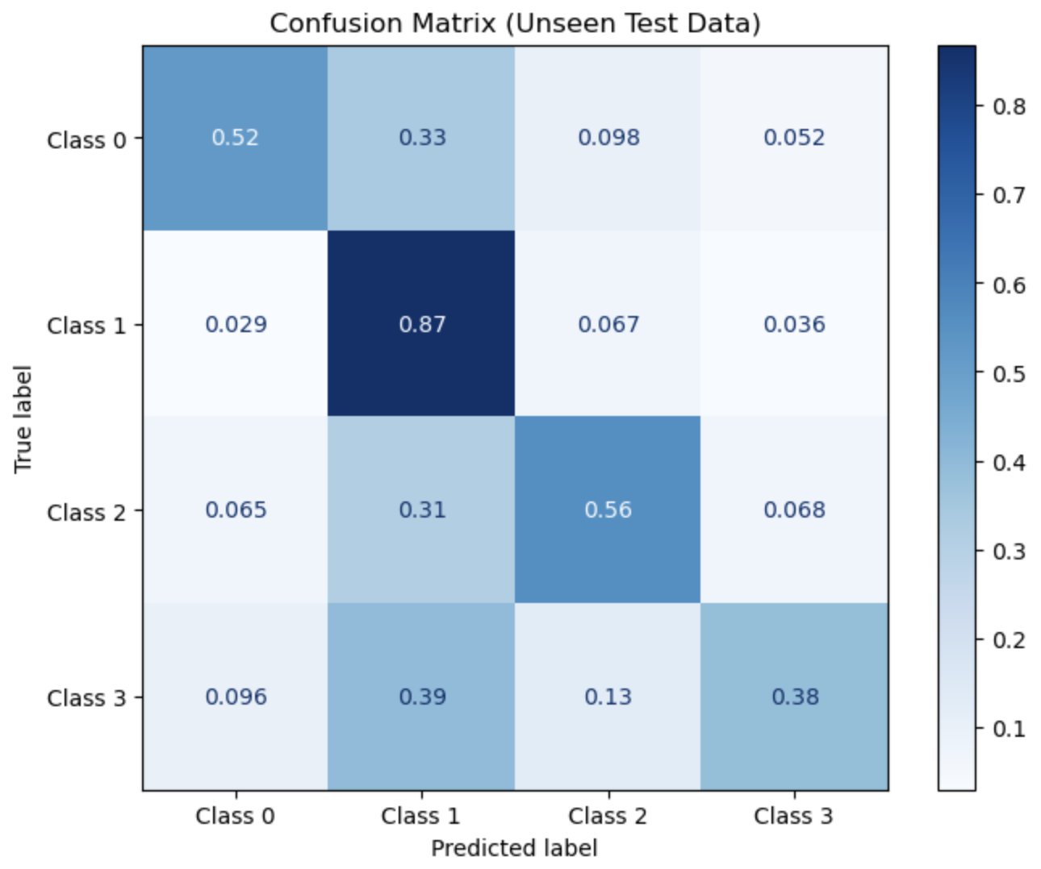

4.5 Lessons Learned
If we were to start again, we would prioritize feature distribution analysis immediately. Recognizing the non-Gaussian nature of the data earlier would have led us to implement the PowerTransformer from the start, bypassing ineffective experiments with standard scaling.

5 Outlier Detection

5.1 Outlier Detection Strategy
Our primary strategy relied on unsupervised density estimation using a Gaussian Mixture Model (GMM).
- Model Training: We trained a GMM (n_components=4, covariance_type='full') on the raw training data. We deliberately avoided feature scaling (StandardScaler), as our experiments demonstrated that scaling compressed the feature space, making outliers harder to distinguish from the tails of normal distributions.
- Labeling Process: To classify an instance x as an outlier, we computed its log-likelihood score under the model. We established a decision threshold τ using the provided reference outlier set (Dout​). By calculating the scores for all samples in Dout​, we set τ to the 99th percentile of these scores.
  - If score(x)<τ: Label as Outlier (1).
  - If score(x)≥τ: Label as Inlier (0).

Alternative Approaches Evaluated: We also attempted a Supervised Learning approach, training a Random Forest as a binary classifier to distinguish between Din​ and Dout​. This approach failed completely (detecting 0 outliers in the test set). The model overfitted by memorizing the specific samples in Dout​ and failed to generalize to new, unseen types of anomalies in the test data. Consequently, we reverted to the robust GMM approach.

5.2 Performance on Inliers Only
When we experimented with training the model exclusively on the inliers (removing the ∼1% of points flagged by the GMM), we observed a slight decrease in Recall for the minority classes (Class 0 and 3).

This indicated that many points identified as statistical outliers were actually valid "hard" examples (edge cases) necessary for defining the class boundaries. Consequently, removing them harmed the model's ability to learn difficult patterns. Our best performance was achieved not by removing training data, but by training on the full dataset and using robust regularization (subsample=0.8) in XGBoost to handle the noise internally, while applying the GMM filter only during the prediction phase.

